Creating applications with J2EE technologies
The Web Application Developer's Guide, Developing Applications with Enterprise JavaBeans, and other parts of JBuilder's documentation explain how to use J2EE technologies. They describe in depth how to use JBuilder features to develop web applications, work with XML, develop Enterprise JavaBeans, access and work with your data using DataExpress, and create web services. Within each of these areas of the documentation, you should find the information to understand these technologies and work productively with them.
But today's web-based enterprise applications usually use several J2EE technologies. How do these disparate technologies fit together in applications you and your team might develop? Which technologies are right for which kind of applications? This chapter intends to help you see how the pieces fit together, while highlighting the flexibility of J2EE applications. It borrows heavily from the Introduction chapter of Designing Enterprise Applications with the J2EE Platform by Inderjeet Singh, Beth Stearns, Mike Johnson, and the Sun Enterprise Team. You can find the book online on the Sun web site at http://java.sun.com/blueprints/guidelines/designing_enterprise_applications_2e/#chapters, and it is also available for purchase.
Here's the diagram from the previous chapter showing the multiple tiers used in most J2EE applications:
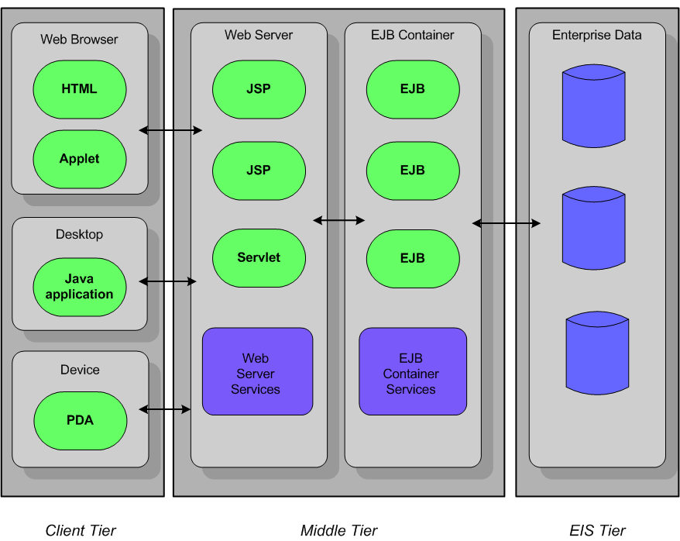
The diagram shows you all the different types of entities found on each tier, but it doesn't show you the common ways J2EE applications combine these technologies to create reliable, scalable, and easily distributed applications.

Client-server applications
Before looking at multi-tier J2EE models, consider the old standard, the two-tier client-server model. Using J2EE technologies does not preclude you from creating client-server applications. Client-server applications omit the middle tier shown in the multi-tier application diagram. While the client-server model scales poorly and maintaining and distributing such applications is more difficult, sometimes a Java client on a desktop that accesses the data of the company directly is all you really need.
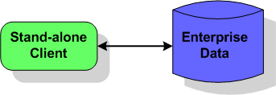
The Java client can contain both the presentation and business logic, although it's possible one application could handle the presentation tasks while another could handle business logic, all on the client tier. You would use JDBC or Connectors to access the data on the Enterprise Information System (EIS) tier.
Consider using the client-server model only when the number of desktops running clients is quite small and will remain so. Once the demand for more than a few client instances increases, you should probably consider another type of application architecture.

Multi-tier applications
Here you see the classic multi-tier, distributed architecture that uses three tiers: the browser on the client tier, the web container and EJB container on the middle tier that runs on a J2EE server, and the Enterprise Information Systems (EIS) tier that is managed by a database system. Such an application uses web components such as JavaServer Pages (JSPs), servlets, and XML to manage the application's presentation logic. The EJB container contains enterprise beans that respond to requests from the web tier components and access the data in the EIS tier.
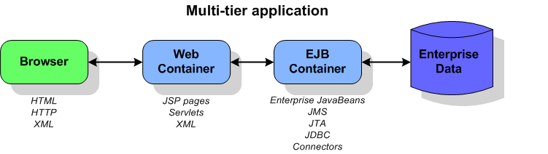
When should you use JavaServer Pages and when should you use servlets? JavaServer Pages are intended as user interface components. Servlets are usually used for processing requests and controlling application logic.
XML can be very important in multi-tier applications. XML data messages use HTTP as their transport protocol. Such data messages can encapsulate all types of data and respond to a variety of client types, including XML-enabled browsers.

Stand-alone clients
Not all multi-tier applications use a browser on the client tier. Often the client is a Java client or a client written in another language that consumes dynamic web content or an application that interacts directly with enterprise beans running in an EJB container. This diagram shows you the possibilities of this type of application:
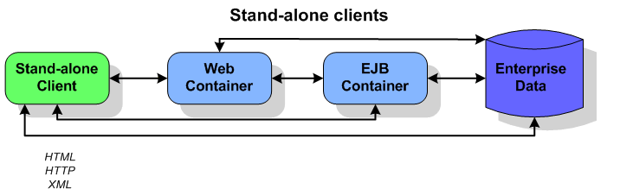
Note that this diagram includes the client-server application also as such an application includes a stand-alone client, too.

Consumers of dynamic web content
One type of stand-alone client is a Java application or another programming language that consumes dynamic web content. This web content is usually XML data messages:
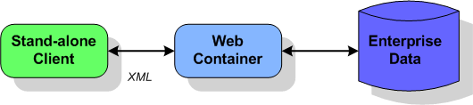
The web container performs the XML transformations and provides web connectivity to clients. The client handles the presentation logic while the web tier manages the business logic and accesses the data on the EIS tier if necessary. Business logic might be implemented as enterprise beans. The J2EE technologies likely to be used are XML, servlets, web services, and possibly enterprise beans and JDBC to access enterprise data.

Java client calling EJBs
Enterprise JavaBeans (EJBs) are server-side components that run in a middle-tier EJB container. The container provides services to the beans, such as transaction management and security. You, as the developer, don't have to implement such low-level and complex services, but instead can concentrate on developing the business logic for the beans, knowing that the services are there when they are needed. Developers often choose EJBs when building applications that will be distributed over several servers. They also like to use EJBs because of the transparent way they handle transactions.
The following diagram depicts a Java client that calls upon the business methods encapsulated with the enterprise beans that are running in an EJB container. If the beans are entity beans, they access company data on the EIS tier through JDBC and J2EE connectors. Ideally, the client should access company data through a session bean which interacts with the entity beans that model company data. A session bean that interacts with an entity bean in this way is usually using the Session Facade design pattern; see "Creating session facades for entity beans" for more information. XML is used in the deployment descriptors for enterprise beans.
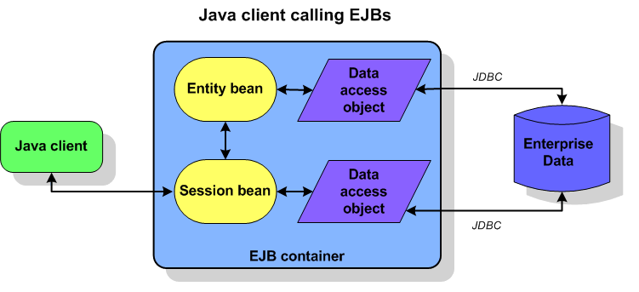
If the application you need requires secure transactions over a distributed system, consider using enterprise beans.

Web-centric applications
There are times when your application just doesn't need to use enterprise beans and if you do so, you add a layer of complexity. If your application doesn't require transactions on a distributed system, consider a web-centric application model:
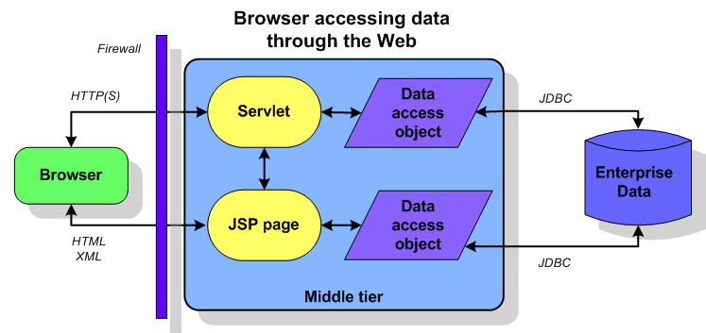
This scenario puts both the presentation and business logic on the web tier. The web container can host JavaServer Pages and servlets. The client is simply a browser and data is transferred using XML, HTTP protocol, and/or HTML pages. Servlets can access the EIS tier, when necessary, using JDBC or connectors. Applications using this type of architecture are quite common.

Business to business
When you need a web-based commerce solution, consider the business-to-business model. This might include multiple web containers and multiple EJB containers.
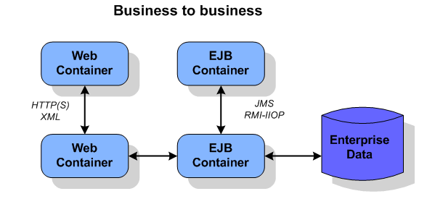
Web container to web container architecture is suitable for ecommerce solutions. Communication takes place through XML data message over HTTP. Such applications are very loosely coupled.
Peer-to-peer communication between EJB containers offers a more tightly coupled model that works well for intranet solutions. In these types of applications, seriously consider using message-driven enterprise beans and Java Message Service (JMS), which enable you to develop loosely coupled applications.

